**A PROJECT REPORT ON CREATING A ITWS WEBSITE**

**­­ USING HTML AND CSS**

**Degree of The Bachelor of Technology** in

Computer science & Engineering (AI&ML).

**Under the guidance of**

**Mr.L.JOHN**

**Submitted by:**

**Name of the student ROLL NO:**

**SHAIK SHAHEID 237R1A66B5**

**VENKATREDDY KARTHIK REDDY 237R1A66C2**

**VENNU ASHRITHA 237R1A66C3**

**SUDANABOINA KALYANI 237R1A66B6**

**Department of Humanities and Science**

**CMR Technical Campus (UGC Autonomous)**

**(NAAC accredited with ‘A’ Grade & NBA accredited)**

**(Approved by AICTE, JNTU HYDERABAD)**

**KANDALAKOYA, MEDCHAL ROAD, HYDERABAD – 501401.**

**TABLE OF CONTENT**

|  |  |  |
| --- | --- | --- |
| **S.NO** | **CONTENT** | **PAGE NO.** |
| **1.** | **Abstract** | **1** |
| **2.** | **Introduction** | **1** |
| **3.** | **Literature Survey** | **2** |
| **4.** | **Analysis and Design** | **3-4** |
| **5.** | **Implementation** | **5** |
| **6.** | **Testing and debugging/result** | **6-7** |
| **7.** | **Conclusion** | **8** |
| **8.** | **Reference** | **8** |

**ABSTRACT:**

This project involves the development of a college laboratory website using HTML and CSS. The website serves as an interactive platform to showcase laboratory information, experiment details, mini projects, faculty details and resources. Through meticulous design and implementation, we ensure user-friendly navigation and aesthetic appeal. HTML forms the structural foundation, defining content hierarchy, while CSS enhances the visual presentation, ensuring a cohesive and engaging user experience. This collaborative effort seamlessly integrates technology with educational needs, providing an accessible and informative online space for students, faculty, and researchers.

**INTRODUCTION:**

In response to the evolving educational landscape, this project embarks on the creation of a dynamic college laboratory website employing the fundamental web technologies of HTML and CSS. Recognizing the crucial role of online platforms in educational communication, the objective is to craft a user-centric and visually appealing interface. HTML lays the groundwork for structuring content, while CSS enriches the presentation, fostering an engaging and intuitive experience. This initiative not only addresses the informational needs of students and faculty but also aligns with the contemporary integration of technology in educational environments.

**LITERATURE SURVEY:**

In recent years, the integration of technology in education has become increasingly prominent, with the development of websites serving as a valuable tool for educational institutions. This literature review explores the utilization of HTML and CSS for creating a website tailored for college laboratories, aiming to enhance the overall learning experience.

This literature review underscores the significance of leveraging HTML and CSS in the creation of a college laboratory website. By prioritizing user-centric design, interactive elements, and integration with existing educational systems, such a website has the potential to enhance the overall learning experience and foster a collaborative and technologically advanced educational environment. Future research could delve into the evolving landscape of web technologies and their impact on educational platforms.

**SYSTEM DESIGN:**

**Here's a basic system design outline using HTML and CSS:**

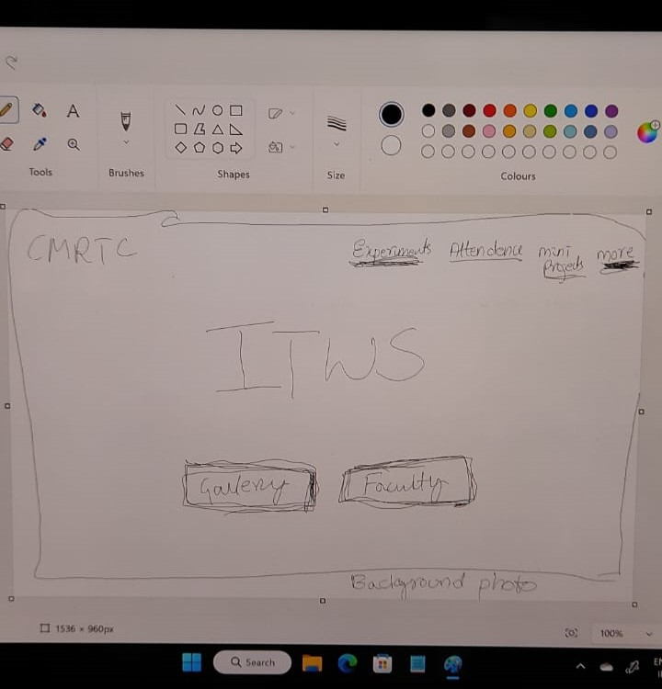

* 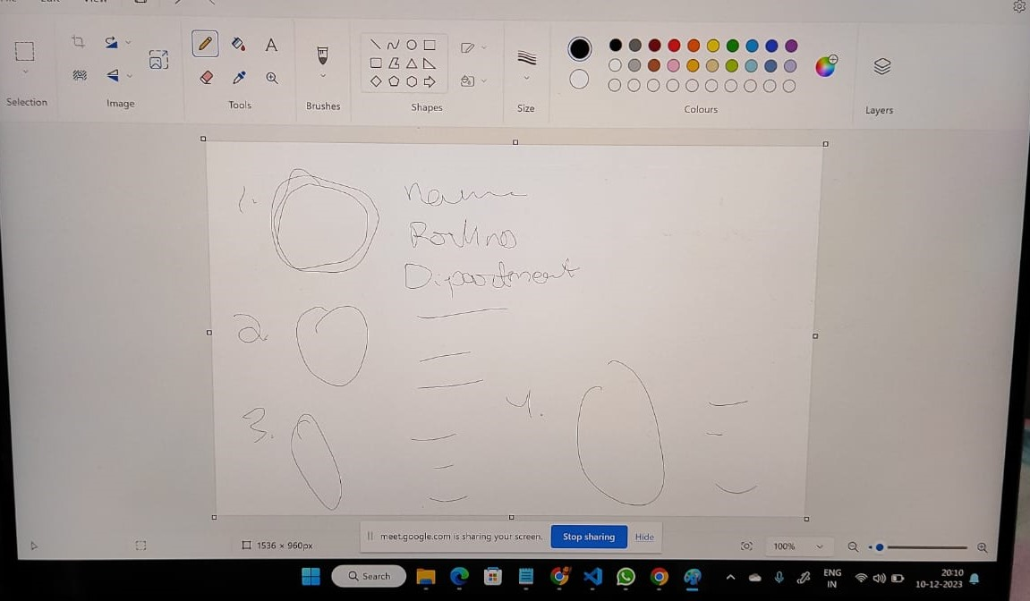 **Rough sketch of our website.**

**1. Design the User Interface:**

**Home Page:**

* Lab name and logo
* Navigation menu.
* Brief overview of the lab.
* Quick links to popular sections.

**About Us:**

* Detailed information about the lab's history, mission, vision, and goals.
* Photos of the lab facilities.

**Facilities:**

* List of equipment and resources available.
* Descriptions and specifications for each piece of equipment.

**Courses/Experiments:**

* A catalog of courses or experiments offered.
* Details on each course/experiment, including prerequisites and outcomes.

**IMPLEMENTION:**

* Start with the frontend, implementing the user interface based on the design.
* Move to the backend to handle server-side logic and data processing.
* Ensure code modularity, readability, and adherence to coding standards.
* Conduct unit testing for individual bulk of code to ensure they function correctly.
* Perform integration testing to verify that different code work together seamlessly.
* Carry out system testing to assess the overall functionality of the website.
* Implement security measures to protect against common vulnerabilities.
* Regularly update dependencies and conduct security audits.
* Assess the website's responsiveness and loading times.
* Optimize codeand assets for improved performance.

**TESTING AND DEBUGGING:**

Testing and debugging are crucial steps in the development process to ensure that your website works correctly and looks good across different devices and browsers.

there are some of them as follows

**1.HTML and CSS Validation:**

* Fixing any errors or warnings reported by tools.

**2. Functional Testing:**

* Testing all interactive elements, such as navigation menus and forms.
* Ensure that links are working correctly and lead to the intended pages.

**3.Debugging:**

* Using browser developer tools to inspect HTML and CSS elements.
* Identifying and fixing any layout issues, broken links, or missing assets.

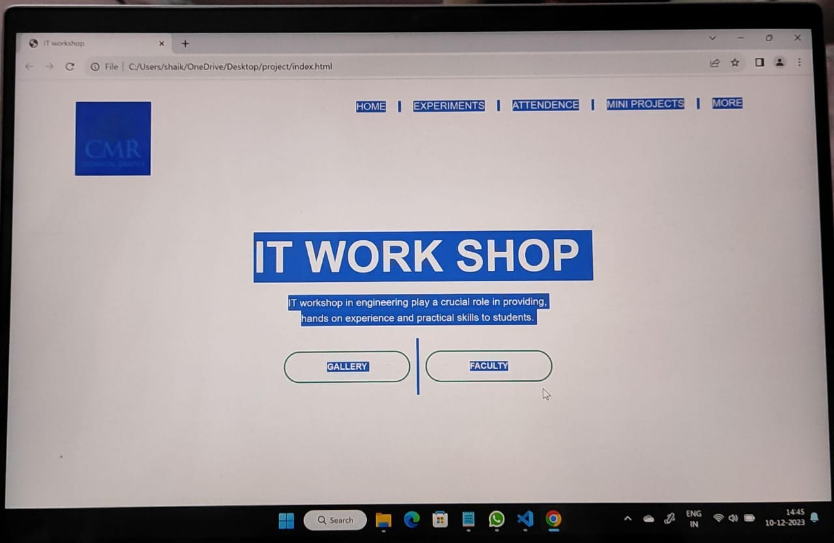

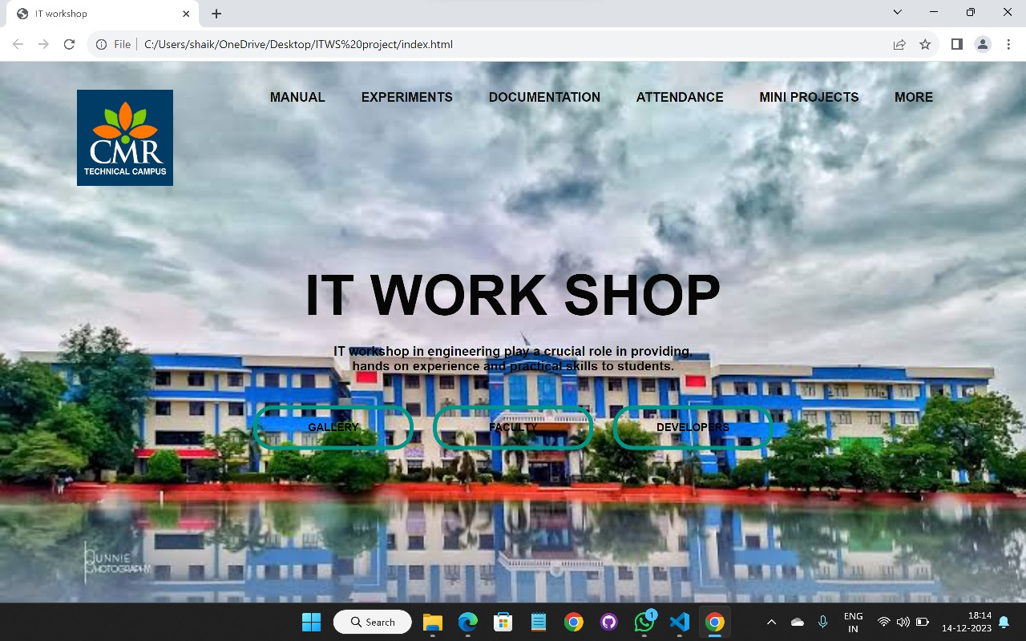

* The primary goal of this project was to create a user-friendly and informative website for the college lab using HTML and CSS. The website aimed to serve as a centralized platform for students, faculty, and visitors to access essential information about the lab, its facilities, on going projects, and relevant resources.

**CONCLUSION:**

The development of the college lab website successfully met its objectives, providing a valuable online platform for information dissemination and community engagement. The user-friendly interface, coupled with visually appealing design, contributes to an enhanced user experience.

The inclusion of key features such as an informative homepage, detailed sections on About lab, Facilities, Projects, faculties, and Contact, has made the website a comprehensive resource.

**REFERENCES :**

* L.john sir
* Open AI
* Youtube
* GeeksforGeeks
* Programiz.com